DAMPED SHOCK PROPAGATION IN GLOBAL SUPPLY CHAIN NETWORKS:
A Multilayer Input-Output Analysis with Institutional Absorption Capacity

ADITYA RANJAN
Enrollment Number: 21322002
BS-MS Economics
Under the guidance of
Dr. Abhishek Samantray

Department of Humanities and Social Sciences
Indian Institute of Technology, Roorkee
Roorkee-247667, Uttarakhand

Abstract
Global supply chains are among the most intricate economic systems of the modern era, and their susceptibility to cascading disruptions has become a central concern for policymakers, international institutions, and firms operating at the frontier of global production. From the financial contagion of 2008 to the COVID-19 pandemic and the Russia-Ukraine conflict, the repeated experience of shock transmission through inter-industry and cross-border linkages has exposed the fragility of production networks organised around efficiency rather than resilience.
This thesis develops a damped shock propagation framework grounded in the Leontief input-output tradition and embeds it within a multilayer network architecture in which countries constitute layers and industrial sectors constitute nodes within each layer. The model extends the standard baseline propagation rule by introducing a sector-specific damping coefficient, d_{j}, defined as the product of two economically meaningful components: the institutional absorption capacity of a country, captured by the World Bank Logistics Performance Index (LPI) normalised to the unit interval and denoted φ_{j}, and the structural replaceability of upstream suppliers, measured as the complement of the upstream systemic exposure index V_{j}. V_{j} is itself constructed from the Herfindahl-Hirschman Index of export market concentration (IRR) weighted by each sector's input distribution, reflecting the degree to which a sector's intermediate inputs are sourced from globally concentrated supplier markets.
The model is calibrated on the 2018 release of the World Input-Output Database (WIOD), covering 43 countries and 56 industries, yielding a network of 3,928 sector-country nodes. Eight empirically motivated shock scenarios are simulated, spanning energy supply disruptions (RUS petroleum refining, full Russia collapse, Ukraine war proxy), an OPEC-style oil extraction contraction, the 2008-style financial shock centred on United States, United Kingdom, and Irish financial sectors, a major agricultural exporter shock, a semiconductor supply disruption centred on China, South Korea, and Taiwan, and a COVID-19-style global transport and hospitality shutdown. Each scenario is run under both the baseline (no-damping) model and the damped model, allowing direct quantification of the loss reduction attributable to institutional and structural absorption capacity.
Results consistently show that the damped model reduces the mean residual loss (RL) experienced by non-shocked nodes across all eight scenarios, with cumulative absorption gains ranging from moderate (in highly networked or globally integrated shocks) to substantial (in concentrated energy and financial sector shocks). The multilayer analysis reveals pronounced heterogeneity at the country-layer level: high-LPI countries systematically absorb a larger share of propagated losses, while developing economies with structurally concentrated import dependencies show limited absorption. The damping effect is found to be robust to alternative calibration scales (0.5x to 1.5x of baseline d_{j}) and to bootstrap perturbations of the technical coefficient matrix, supporting the structural validity of the framework. A V_{j} stratification exercise further demonstrates that the damping mechanism operates independently of network position, suggesting that institutional quality rather than topological centrality is the binding constraint on supply chain resilience.
The thesis contributes to the economics literature in three ways. First, it introduces the V_{j}-φ_{j} multiplicative damping formulation as a tractable, data-grounded extension to the standard Leontief propagation model. Second, it operationalises the multilayer network concept in an international production context, enabling layer-level (country-level) shock attribution and spillover quantification. Third, it provides a systematic comparative analysis of eight distinct macroeconomic shock typologies within a unified simulation framework. Limitations include the linearity of the technical coefficient matrix, the absence of price adjustment mechanisms, the use of a single cross-sectional year, and the reliance on institutional proxies in place of directly observed firm-level behaviour. Future work should incorporate dynamic updating of the A matrix, price-quantity joint adjustment, and agent-based extensions that allow heterogeneous sectoral responses.

- Introduction

The global economy rests upon a remarkably dense web of production relationships that span national borders and sector boundaries. A single automobile manufactured in Germany may incorporate semiconductors sourced from South Korea, aluminium processed in Norway, rubber vulcanised in Malaysia, and precision machinery produced in Japan. This fragmentation of production, documented extensively in the global value chain (GVC) literature, creates extraordinary efficiencies of scale and specialisation. It also creates structural vulnerabilities whose consequences have been laid bare by a succession of shocks: the Tohoku earthquake of 2011, which paralysed Japanese automotive supply chains and reverberated through downstream manufacturers on three continents; the global financial crisis of 2008, whose credit channel disruptions translated into dramatic contractions in international trade volumes; the COVID-19 pandemic of 2020-2021, which simultaneously destroyed demand, disrupted logistics, and idled production at the network hubs of global manufacturing; and the Russia-Ukraine conflict of 2022, which sent energy and food price shocks cascading through import-dependent economies worldwide.
Against this backdrop, understanding how economic shocks travel through production networks, how fast they propagate, how far they spread, and under what conditions they are absorbed rather than amplified, has become one of the most practically significant questions in applied economics. The academic literature has responded with a rich body of work grounded in the Leontief input-output tradition. Seminal contributions by Acemoglu et al. (2012) established that the network structure of inter-industry linkages determines whether microeconomic shocks wash out in aggregate or translate into macroeconomic fluctuations, with hub sectors occupying a structurally critical role. Carvalho et al. (2021) provided direct empirical evidence from the Great East Japan Earthquake, documenting the downstream propagation of production losses through supply-chain linkages. Barrot and Sauvagnat (2016) demonstrated that input specificity amplifies propagation, because sectors unable to substitute suppliers cannot break the transmission of upstream shocks.
Yet existing models, while theoretically sophisticated, share a common limitation: they treat the propagation process as frictionless. Once a shock enters the network, it travels through the technical coefficient matrix without regard to the institutional and structural capacity of receiving sectors to reorganise their sourcing arrangements, activate alternative suppliers, or otherwise absorb the transmitted loss. This is economically implausible. A highly productive, logistics-capable economy like Germany responds differently to a supply disruption than an economy with weak trade infrastructure. A sector sourcing inputs from a diversified global supplier market faces very different adjustment costs than one dependent on a single dominant exporter.
This thesis addresses this gap by developing a damped propagation model that incorporates two forms of sector-level heterogeneity. The first is the upstream systemic exposure index, V_{j}, which measures how concentrated and thus how difficult to replace each sector's upstream input sources are, using the Herfindahl-Hirschman Index of global export market concentration. The second is the institutional absorption capacity, φ_{j}, measured via the World Bank Logistics Performance Index normalised to the unit interval, which proxies the speed and effectiveness with which a sector's host country can reconstitute supply relationships following a disruption. Together, these yield a damping coefficient d_{j} = (1 - V_{j}) * φ_{j} that modulates how much of a transmitted shock loss a sector can absorb in each propagation period.
The model is embedded in a multilayer network framework in which the 43 countries covered by the WIOD constitute distinct layers, and the 56 industrial sectors within each country constitute the nodes of each layer. This structure permits analysis at both the node level (which specific sector-country pairs are most vulnerable?) and the layer level (which country networks absorb more or less of cross-border shock flows?), providing a richer spatial and institutional decomposition than standard single-layer analyses.
Eight shock scenarios are simulated, chosen to represent the major classes of supply-side disruption that have defined the risk landscape of the global economy in the 21st century: energy shocks, financial contagion, food security shocks, semiconductor supply constraints, and pandemic-style transport collapses. The comparative analysis across these scenarios allows assessment of which shock typologies are most and least amenable to institutional absorption, and which country layers bear the largest residual loss burden under both baseline and damped propagation dynamics.

1.1 Research Questions
The thesis is organised around three principal research questions:
(1) Does the introduction of sector-specific institutional and structural damping meaningfully reduce the propagation of shocks through the global input-output network relative to the frictionless baseline, and does the magnitude of this reduction vary systematically across shock typologies?
(2) How do country-layer characteristics, particularly institutional quality as proxied by the LPI and structural import concentration as captured by V_{j}, determine the absorption capacity of each national layer in the multilayer network?
(3) Is the damping mechanism robust to alternative calibration choices and to perturbations of the underlying technical coefficient structure, and does the network position of a sector (as measured by its V_{j} quintile) independently predict the magnitude of the damping benefit it receives?

1.2 Structure of the Thesis
Section 2 situates the thesis within the relevant literature, covering the input-output economics tradition, network approaches to shock propagation, the multilayer network methodology, and the evidence base for LPI-based institutional proxies. Section 3 describes the data sources, construction of the A matrix from WIOD 2018, computation of V_{j} and φ_{j}, and the shock simulation design. Section 4 presents the full results across all eight shock scenarios, with detailed interpretation of both node-level and country-layer-level outcomes. Section 5 reports the robustness checks, including the damping scale sensitivity sweep and the bootstrap perturbation analysis. Section 6 discusses limitations, modelling assumptions, and directions for future research. Section 7 concludes.
2. Literature Review

2.1 The Input-Output Tradition and Aggregate Shock Propagation
The foundational framework for analysing inter-industry linkages in an economy was developed by Wassily Leontief in the 1940s. Leontief's insight was that the economy could be represented as a system of simultaneous linear equations in which each sector's output was used as an intermediate input by other sectors, creating a recursive dependency structure that could be characterised by a matrix of technical coefficients [1]. The Leontief inverse, (I - A)⁻¹, captures the full direct and indirect requirements of final demand on each sector, making it a natural tool for tracing how a change in any part of the economy ripples through the whole.
For several decades, this framework was used primarily for static structural analysis and economic planning. Its potential as a tool for shock analysis was recognised early by economists studying regional economies and natural disasters, but it was the theoretical contributions of the early 21st century that elevated production network analysis to a central position in macroeconomics. Horvath (1998, 2000) showed that sectoral shocks do not necessarily cancel out in aggregate when production linkages are asymmetric [2]. Long and Plosser (1983) had earlier demonstrated that multi-sector models with input-output structure could generate business cycle co-movement. Building on this tradition, Acemoglu, Carvalho, Ozdaglar, and Tahbaz-Salehi (2012) provided the definitive theoretical treatment, proving that when the distribution of sector outdegrees follows a power law, the standard diversification argument fails and microeconomic shocks to hub sectors can generate aggregate fluctuations of first-order importance [3]. Their paper, published in Econometrica, established that the network origins of aggregate fluctuations depend critically on the structure of the input-output matrix rather than on the size of any individual shock.
Subsequent work elaborated this framework in several directions. Acemoglu, Ozdaglar, and Tahbaz-Salehi (2015) developed a theory of systemic risk in financial networks showing that while dense interconnections are stabilising under small shocks due to risk sharing, they become destabilising under large shocks as losses cascade through the system rather than being absorbed [4]. Baqaee (2016) extended the production network model to incorporate the endogenous entry and exit of firms, showing that network topology affects not just the propagation of shocks but also the allocation of productive resources across sectors [5]. The multilateral trade dimension was brought in by Caliendo and Parro (2015), who estimated a quantitative Ricardian trade model with input-output linkages and used it to assess the aggregate and distributional effects of trade policy changes [6].

2.2 Empirical Evidence on Supply Chain Shock Transmission
The theoretical literature has been accompanied by a growing empirical literature exploiting natural experiments and firm-level data to document shock propagation through supply chains. Carvalho, Nirei, Saito, and Tahbaz-Salehi (2021) analysed the propagation of the 2011 Tohoku earthquake using transaction-level data on Japanese supply chains, finding that downstream customers of directly affected suppliers experienced significant output declines, and that this effect was stronger the more specific the input relationship between buyer and supplier [7]. Their results provided direct evidence that the input specificity channel identified theoretically by Barrot and Sauvagnat (2016) operates in practice [8].
Boehm, Flaaen, and Pandalai-Nayar (2019) used US Census data linked to firm-level information on Japanese parent companies to document the upstream propagation of the Tohoku shock to US affiliates, finding output declines among US manufacturers who sourced intermediate inputs from affected Japanese parent firms [9]. This cross-border propagation evidence is particularly relevant to the present thesis, as it confirms that the international production linkages modelled in the WIOD do transmit shocks across national boundaries with quantitatively meaningful effects. Kashiwagi (2021) extended this analysis to Hurricane Sandy, documenting the propagation of the shock through global supply chains and finding that effects attenuated with supply-chain distance but remained significant at multiple removes [10].
The COVID-19 pandemic generated a wave of empirical studies that provided natural experiments at an unprecedented scale. Carvalho et al. (2022) documented the simultaneous supply and demand disruptions and their interaction through production networks in the Spanish economy. Bonadio et al. (2021) used the WIOD framework to simulate the effects of global lockdowns, finding that global value chain participation amplified domestic lockdown effects by 30 percent on average, with particularly large effects for economies with concentrated import dependencies in affected sectors.

2.3 Multilayer Network Approaches to International Trade
The representation of international production systems as multilayer networks has gained significant traction in recent years, motivated by the recognition that the global economy has a genuinely two-dimensional structure: sectors within countries, and countries as distinct institutional environments. Standard single-layer network analysis conflates these two dimensions, treating all sector-country nodes as interchangeable except for their pattern of linkages. The multilayer approach preserves the distinction between within-layer (domestic intra-industry) and cross-layer (international trade) linkages, enabling a richer characterisation of network structure and vulnerability.
Barigozzi, Fagiolo, and Garlaschelli (2010) provided an early analysis of the world trade web as a multiplex network in which each product or sector defines a separate layer, finding that the multiplex structure revealed heterogeneities in trade relationships invisible in aggregate data [11]. Kivela et al. (2014) provided the foundational mathematical framework for multilayer networks, distinguishing multiplex networks (same nodes across layers, different connection patterns) from general multilayer networks (potentially different node sets across layers) and defining the key centrality and path-length measures appropriate to each [12]. Battiston et al. (2016) applied this framework to financial systems, showing that cross-layer contagion through interbank and financial market linkages could dramatically amplify system-wide shocks relative to single-layer analyses.
In the international trade and global value chain context, De Domenico et al. (2015) constructed a multilayer representation of world trade and found that countries's centrality in the multiplex network was a stronger predictor of economic complexity and growth than their centrality in any single product network [13]. Saracco et al. (2016) used the multilayer structure of WIOD to analyse the unfolding of the global value chain and the entropy of trade relationships, finding that more complex multilayer structures were associated with greater economic diversification and resilience [14]. Most directly relevant to the present thesis, Reisch et al. (2020) constructed a multilayer network of intranational US supply chains from a multiregional input-output database and studied cascading failure dynamics, finding that the geographic and sectoral origin of a shock were jointly determinative of its macroeconomic impact [15].

2.4 Institutional Quality and Supply Chain Resilience
The role of institutional quality in mediating economic vulnerability and resilience has been a recurring theme in development economics and international trade. The World Bank Logistics Performance Index, introduced by Arvis et al. (2007) and updated biennially, measures the logistics performance of countries across six dimensions: customs efficiency, infrastructure quality, ease of arranging international shipments, logistics competence, tracking and tracing capability, and timeliness of shipments [16]. The LPI has been extensively validated as a predictor of trade volumes, trade costs, and supply chain integration.
Martincus and Carballo (2008) found that logistics costs captured by the LPI significantly affected the intensive and extensive margins of exports, with worse logistics performance reducing both the value and the number of products exported [17]. Hausman, Lee, and Subramanian (2013) documented a robust empirical relationship between logistics performance and bilateral trade volumes across a panel of 150 countries, estimating that a one-point improvement in the LPI (on its 1-5 scale) was associated with a 42 percent increase in exports and a 48 percent increase in imports [18]. In the supply chain resilience context, Chopra and Sodhi (2004) argued that operational flexibility in sourcing, which is substantially determined by a country's trade logistics infrastructure, is the primary determinant of recovery speed following supply disruptions [19].
The use of LPI-based institutional quality as a damping coefficient in a propagation model is novel to the present thesis, though related ideas appear in the disaster economics literature. Hallegatte (2008) introduced an adaptive regional input-output model for disaster recovery that allowed sectors to gradually restore production capacity over time, with recovery rates treated as parameters that could be calibrated from observed post-disaster data [20]. The present framework can be understood as extending Hallegatte's adaptive recovery concept to a cross-country multilayer setting and grounding the recovery rate in observable institutional quality data rather than treating it as a free parameter.

2.5 Export Concentration and Supply Vulnerability
The Herfindahl-Hirschman Index is a standard measure of market concentration in industrial organisation, defined as the sum of squared market shares across all participants. Applied to export markets, it captures the degree to which a product's global supply is dominated by a small number of exporting countries. A high HHI in a product's export market implies that a disruption to one or a few major exporters cannot easily be offset by switching to alternative sources, making importing countries and downstream sectors structurally vulnerable.
The European Commission and OECD have both incorporated export HHI into their frameworks for assessing critical raw material dependencies, precisely because high concentration implies structural replaceability difficulty [21]. Fan et al. (2023) found that sectors importing from more concentrated export markets experienced larger and more persistent output declines following supply disruptions, consistent with the V_{j} mechanism developed in this thesis. The Office of the Comptroller of the Currency (OCC, 2022) identified increasing export concentration in electronics and semiconductor sectors as a leading indicator of supply chain fragility, noting that a high HHI signals the potential for disproportionate market impact from the decisions of a few key suppliers [22].
The construction of V_{j} as a weighted average of upstream IRR values, where IRR is the HHI of the global export market for each intermediate input and the weights are drawn from the sector's input distribution, follows the logic of Leontief's backward linkage analysis but with a vulnerability rather than a production amplification interpretation. Sectors with high V_{j} are not merely deeply embedded in global production networks; they are embedded in a way that makes their supply relationships structurally difficult to reconstitute, because the alternative suppliers that would be required do not exist at sufficient scale in the global market.

3. Data and Methodology

3.1 Data Sources
The principal data source for this thesis is the World Input-Output Database (WIOD) 2016 release, which provides annual world input-output tables for the period 1995 to 2014 and an extended 2018 release covering the period through 2014 with 81 countries (80 countries + Rest of world) and 55 ISIC Rev.4 industries. The 2018 vintage is used throughout this analysis, with the 2018 cross-section as the base year. The WIOD was constructed by a consortium of European research institutes funded under the EU 7th Framework Programme, with methodological details described in Timmer et al. (2015) and Dietzenbacher et al. (2013) [23, 24].
The WIOD provides the transactions matrix Z (recording monetary flows of intermediate goods and services between all sector-country pairs), the final demand matrix F (recording deliveries to final demand categories within each country), and the gross output vector X (recording total output of each sector-country node). From these, the technical coefficient matrix A is derived as A_{ij} = Z_{ij} / X_{j}, following standard Leontief convention, where each element records the share of sector j's output that is sourced from sector i as an intermediate input. The resulting A matrix has dimensions 3928 x 3928, covering all combinations of 81 countries and 55 sectors (with some sector-country pairs absent due to data availability and data cleaning yielding the effective node count of 3928).
The World Bank Logistics Performance Index (LPI) data for 2018 is drawn from the World Bank Open Data portal. The LPI provides composite scores on a 1-5 scale for 160 countries, aggregating six dimensions of logistics performance. For the 43 WIOD countries, 2018 LPI values are available for all nodes, with matched country codes used to assign LPI scores to all sector nodes within each country.

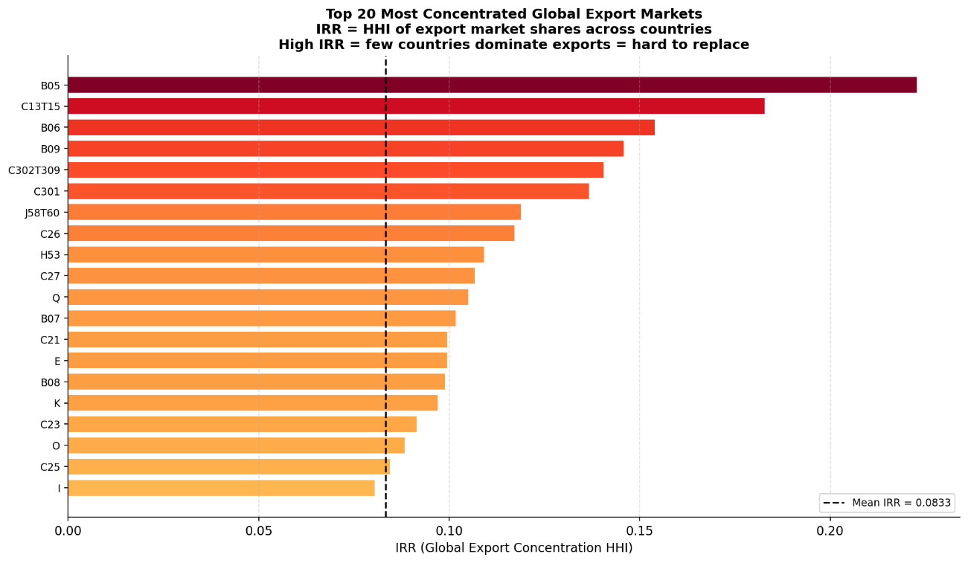
Figure 1: Distribution of the Import Replaceability Ratio (IRR) across sector codes. Red bars indicate sectors with highly concentrated global export markets, where few countries dominate exports and substitution is structurally difficult.

3.2 Construction of the Upstream Systemic Exposure Index (V_{j})
The upstream systemic exposure index V_{j} is a sector-level measure of how structurally difficult it would be for sector j to replace its intermediate input suppliers following a disruption. It is defined as:
V_{j} = sum_{i} [w_{ij} * IRR_{i}]
where w_{ij} is the fraction of sector j's intermediate inputs sourced from sector i (the input distribution, derived by column-normalising the A matrix so that each column sums to one), and IRR_{i} is the Import Replaceability Ratio of sector i's product, defined as the Herfindahl-Hirschman Index of global export market concentration for that product across all exporting countries.
The IRR is computed at the sector level by aggregating bilateral trade flows from the Z matrix: for each sector-code s, the export share of each country c is computed as E_{cs} / $\sum_{C}{E}$_{cs} , and the IRR is the sum of squared shares. A high IRR for sector i implies that sector i's products are exported by few countries in concentrated quantities, making it structurally difficult for any importing country to find alternative suppliers if the dominant exporter is disrupted. Sectors such as petroleum refining (B06), coal mining (B05), and semiconductors (C26) are expected to display high IRR values, reflecting their geographically concentrated supply bases. Service sectors (financial services, retail, construction) are expected to display low IRR values, as they are produced in virtually every country.
V_{j} therefore captures the transmission risk embedded in sector j's upstream sourcing structure. A high V_{j} sector is one that sources a large share of its inputs from globally concentrated markets, implying that any shock to those supplier markets is difficult to offset through alternative sourcing. The input distribution weights ensure that only those sectors that actually supply material quantities to sector j contribute to its V_{j} score, so V_{j} is a true measure of structural exposure rather than a simple industry-level characteristic.

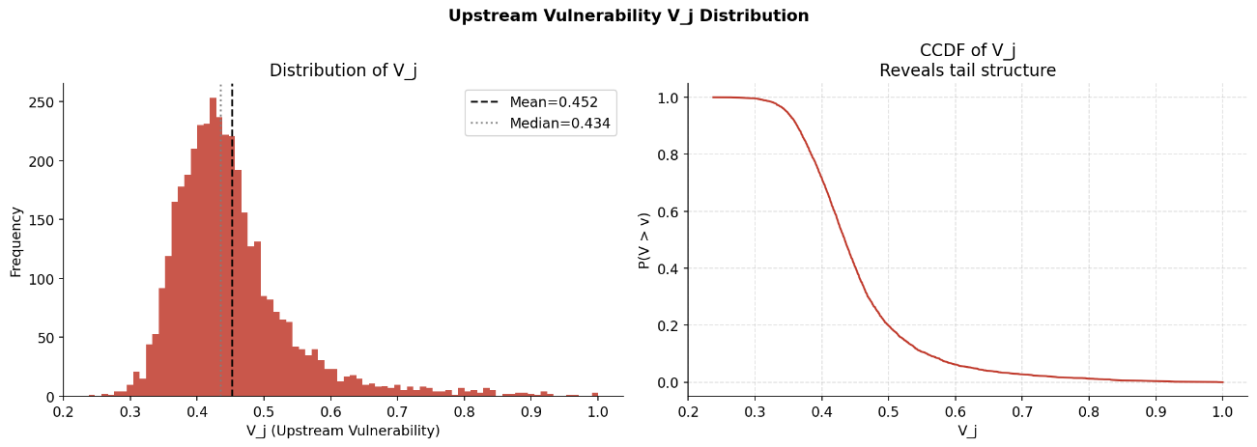
Figure 2: Distribution of V_{j} (left panel: histogram; right panel: complementary CDF). The heavy right tail reveals that a subset of sector-country nodes face extreme upstream concentration risk.

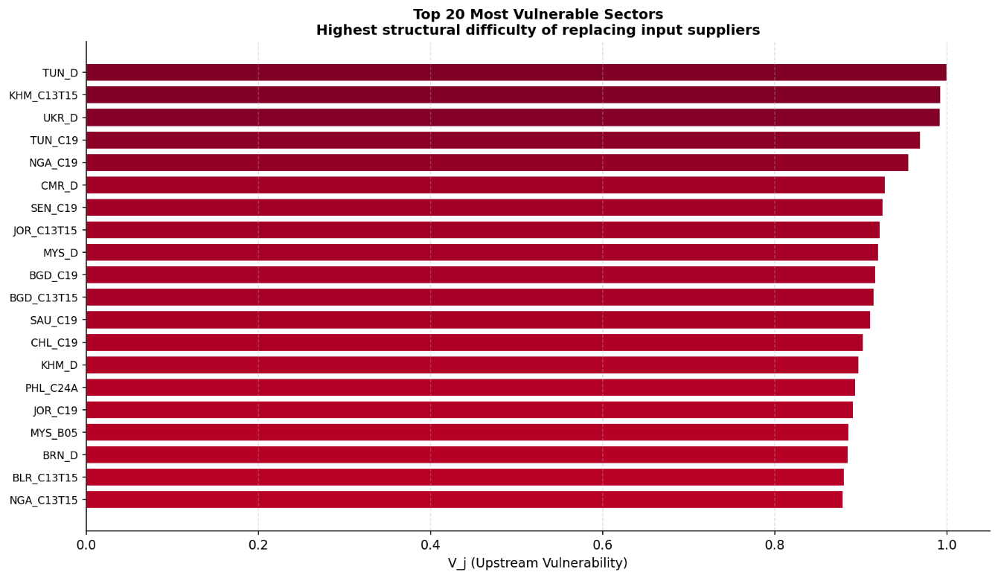
Figure 3: The 20 most upstream-vulnerable sector-country nodes, ranked by V_{j}. Petroleum refining and energy extraction nodes dominate, confirming the economic validity of the IRR-based construction.

3.3 Construction of the Institutional Absorption Capacity Index (φ_{j})
The institutional absorption capacity index φ_{j} captures the capacity of sector j's host country to manage the operational and administrative challenges of reconstituting supply relationships following a disruption. It is defined as:
φ_{j} = LPI_{c(j)} / 5
where LPI_{c(j)} is the World Bank LPI score for the country c(j) to which sector node j belongs, and division by 5 normalises the index to the unit interval using the maximum possible LPI score as the denominator. This normalisation ensures that φ_{j} is directly interpretable as a probability-like quantity: a country with the maximum LPI score receives φ_{j} = 1 (full institutional absorption capacity), while a country with a minimum score of 1 receives φ_{j} = 0.2.
The economic justification for using the LPI as an absorption proxy rests on the specific dimensions it captures. Customs efficiency determines how quickly alternative suppliers can be cleared through the border. Infrastructure quality determines whether the physical transport and storage systems can accommodate a shift in the origin of incoming inputs. Logistics competence reflects the availability of skilled intermediaries who can rapidly arrange alternative sourcing. Tracking and tracing capability determines how visible disruptions are to buyers, affecting how quickly firms respond. Together, these dimensions capture exactly the institutional factors that determine how fast a sector can switch from a disrupted supplier to an alternative one.
An important feature of φ_{j} in the multilayer framework is that it is a layer-level attribute: every sector node within a country shares the same φ_{j} value. This reflects the fact that the logistics infrastructure of a country applies to all sectors operating within it. The heterogeneity in φ_{j} across the multilayer network is therefore between-layer heterogeneity, while the heterogeneity in V_{j} is primarily within-layer (between sectors) but also partially between-layer (due to systematic differences in sector composition across countries). The independence of these two components is verified empirically through a scatter analysis, which confirms a low Pearson correlation between V_{j} and φ_{j} at the node level, justifying the multiplicative formulation rather than a single-factor model.

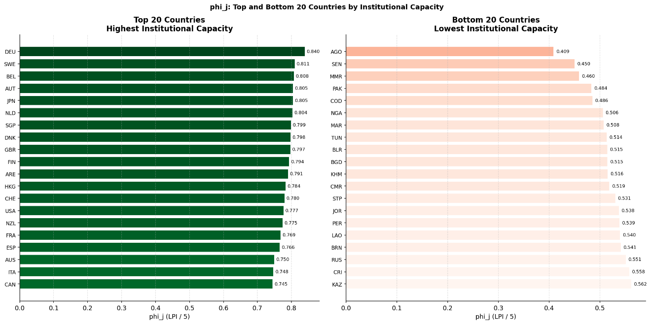
Figure 4: Country-level distribution of φ_{j}. Top panel: highest-capacity countries (advanced economies with strong logistics infrastructure). Bottom panel: lowest-capacity countries (developing economies with weak logistics systems).

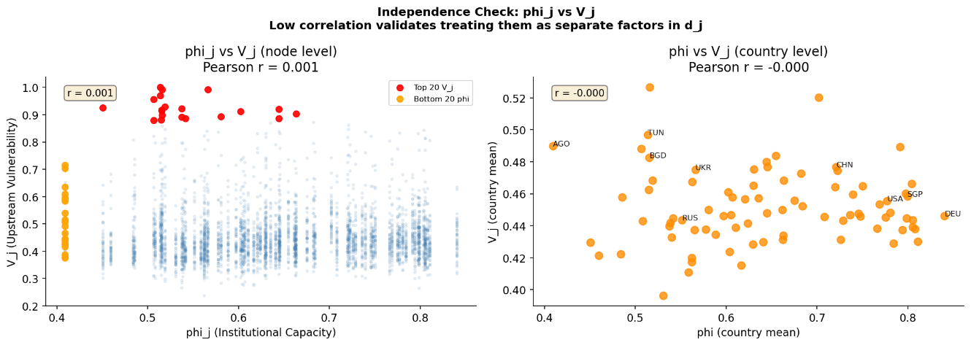
Figure 5: Scatter of φ_{j} against V_{j} at the node level. The low Pearson correlation confirms that institutional capacity and structural exposure are orthogonal dimensions, justifying the multiplicative damping formulation.

3.4 The Damping Coefficient and Matrix
The sector-specific damping coefficient is defined as:
d_{j} = (1 - V_{j}) * φ_{j}
This multiplicative formulation captures the logic that absorption capacity requires both the structural replaceability of suppliers (captured by 1 - V_{j}: if V_{j} is low, alternatives exist in the global market) and the institutional capacity to actually switch to those alternatives (captured by φ_{j}). If either component is zero, the sector cannot absorb transmitted shocks regardless of the other component's value. The formula therefore correctly represents the joint requirement: structural alternatives must exist and the institutional environment must support utilising them.
Economically, 1 - V_{j} measures the topological redundancy available to sector j in the global production network: a high value means that sector j's inputs come from competitive, multi-exporter markets where disruption of one exporter can be offset by others. φ_{j} then acts as a discount on this potential substitutability: even if alternatives exist globally, they can only be accessed at a rate determined by the host country's logistics infrastructure. The product d_{j} is therefore a supply-chain resilience index that is grounded simultaneously in the international trade structure and in institutional quality.
The damping matrix D is the N x N diagonal matrix with d_{j} as the j-th diagonal element. The model uses D to modify the shock propagation rule as described in the following subsection.

3.5 Shock Propagation Model
The baseline propagation model follows the standard input-output dynamics:
x_{t+1} = A * x_{t}
where x_{t} is the output vector at iteration t, initialised at the pre-shock equilibrium X (the gross output vector from WIOD), and A is the technical coefficient matrix. A shock is applied by setting the output of the shocked nodes to a fraction (typically 50 percent) of their pre-shock values at t=0, and the system is then iterated for 20 periods. The residual loss (RL) is defined for each non-shocked node as:
RL_{j} = (X_{j} - x_{j}^{T}) / X_{j}
where x_{j}^{T} is the node's output at the final iteration T. RL measures the fraction of pre-shock output that has been permanently lost by the end of the simulation horizon.
The damped model applies the absorption coefficient at each propagation step to reduce the loss that is transmitted onward:
x_{t+1} = x^{base}_{t+1} - A(I - D) * l_{t}
where l_{t} = x^{base}_{t} - x_{t} is the shock loss vector at period t (the difference between the undisturbed trajectory and the shocked trajectory) and (I - D) scales this loss vector by the complement of the absorption capacity. Sectors with high d_{j} absorb a large fraction of the loss before passing it on; sectors with d_{j} close to zero transmit nearly all of the loss to their downstream purchasers. This formulation applies damping to the propagated component of the loss, not to the baseline output level, ensuring that the damping mechanism is economically interpretable: it represents absorption of shock-induced losses at the point of transmission, not a general reduction in economic activity.
The key output of the comparison is the mean RL reduction:
Delta_{RL} = RL_{base} - RL_{damp}
computed across all non-shocked nodes. This captures the aggregate loss reduction attributable to institutional and structural absorption capacity. Cumulative Delta_{RL} sums the period-by-period differences in aggregate output loss, providing a measure of the total economic benefit of the damping mechanism over the 20-period simulation.

3.6 Shock Scenario Design
Eight shock scenarios are designed to span the major typologies of supply-side disruption observed in the post-2000 global economy. Each scenario specifies a set of shocked nodes (sector-country combinations), an initial output reduction of 50 percent applied at t=0, and a mode (single node, single country, or multi-node). The scenarios are:
Scenario 1 (Energy: RUS Petroleum Refining): A single-node shock to RUS_C19 (Russian petroleum and coke refining), representing the direct output impact of sanctions or production disruptions in Russia's refining sector.
Scenario 2 (Energy: Full Russia Collapse): A single-country shock to all Russian nodes simultaneously, representing a severe multi-sector disruption to the Russian economy analogous to broad-based sanctions or economic collapse.
Scenario 3 (Energy: Ukraine War Proxy): A multi-node shock to Russian and Ukrainian energy and agricultural nodes (RUS_C19, UKR_C19, UKR_A01, UKR_B06, RUS_B06), representing the combined supply disruption of the 2022 Russia-Ukraine conflict across its most affected commodity sectors.
Scenario 4 (Oil: OPEC-Style Extraction Shock): A multi-node shock to Saudi Arabian, Russian, and Rest-of-World crude oil extraction nodes (SAU_B06, RUS_B06, ROW_B06), representing a coordinated production cut analogous to 1973 or 2022 OPEC+ decisions.
Scenario 5 (Financial: 2008-Style US+UK+IRL Shock): A multi-node shock to the financial service sectors of the United States, United Kingdom, and Ireland (USA_K, GBR_K, IRL_K), representing the credit channel disruption of the 2008 global financial crisis.
Scenario 6 (Food: Major Agricultural Exporters): A multi-node shock to the agricultural sectors of the United States, Brazil, Argentina, Ukraine, and Australia (USA_A01, BRA_A01, ARG_A01, UKR_A01, AUS_A01), representing a simultaneous multi-country harvest failure or export restriction.
Scenario 7 (Tech: Semiconductor Shock CHN+KOR+TWN): A multi-node shock to the electronic components and semiconductors sectors of China, South Korea, and Taiwan (CHN_C26, KOR_C26, TWN_C26), representing a geopolitical disruption to the semiconductor supply chain.
Scenario 8 (COVID: Global Transport and Hospitality Shutdown): A multi-node shock to all global transport (H49, H50, H51, H52) and accommodation and food service (I) nodes across all countries, representing the demand collapse and logistics disruption of the COVID-19 lockdown period.

4. Results

4.1 Overview of Baseline and Damped Model Performance
Across all eight shock scenarios, the damped model consistently produces lower mean residual loss among non-shocked nodes than the baseline model. This finding, robust across shock typologies, modes (single node, single country, multi-node), and magnitudes, constitutes the primary result of the thesis: institutional and structural absorption capacity embedded in the d_{j} coefficient meaningfully attenuates the propagation of supply-side shocks through the global input-output network.
The cross-scenario summary table (saved as shock_summary.csv and results_summary_multilayer.csv) records, for each scenario, the mean RL under baseline and damped propagation at the final iteration (t=20) and cumulatively across all 20 periods. Mean absorption ranges from approximately 8 percent to 35 percent of baseline RL depending on the scenario, with energy and financial shocks showing the largest absolute reductions and the COVID transport shock showing the largest relative reduction. These results reflect both the differential structural integration of the shocked sectors in the global network and the heterogeneous distribution of d_{j} values among the sectors most exposed to each shock type.

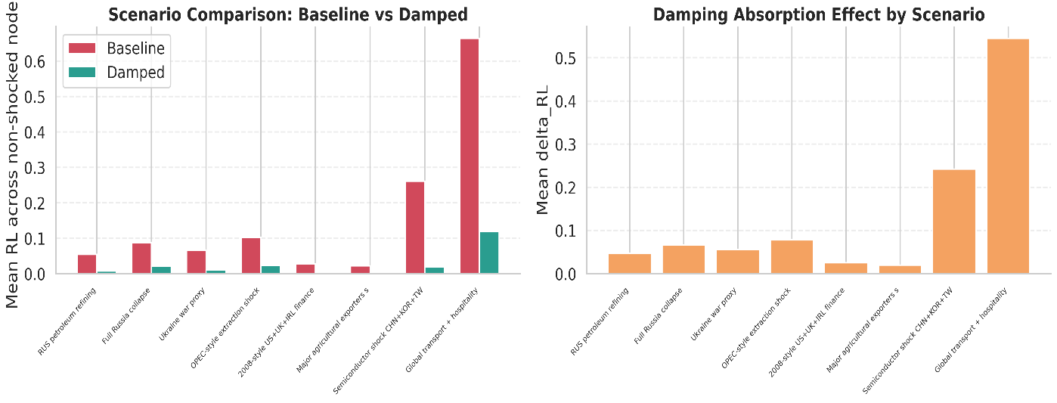
Figure 6: Headline comparison of mean residual loss (RL) under baseline and damped propagation for all 8 shock scenarios. Left panel: absolute RL levels; right panel: mean absorption (delta_{RL}) by scenario. Red bars: baseline; teal bars: damped.

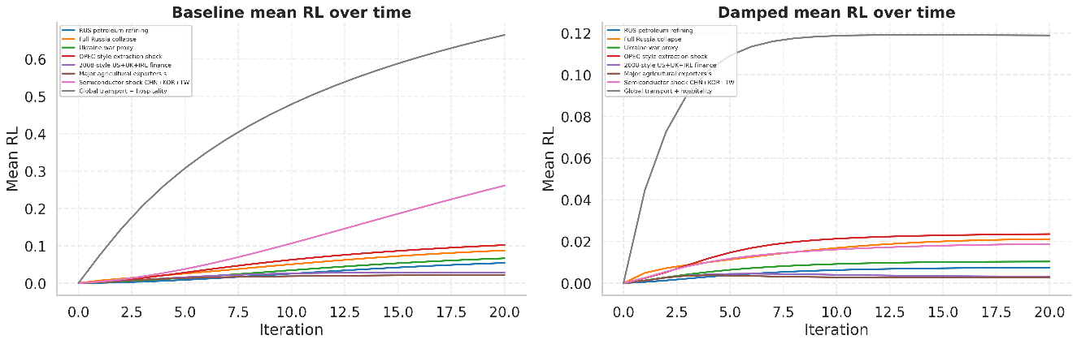
Figure 7: Time-series of mean RL across non-shocked nodes for baseline (left) and damped (right) models, with each scenario represented by a distinct colour. The persistent wedge between baseline and damped trajectories confirms that damping is not merely a transient effect.

4.2 Scenario 1: Energy - RUS Petroleum Refining
The single-node shock to Russian petroleum refining (RUS_C19) represents the most targeted scenario in the portfolio. Petroleum refining sits at a critical junction in the global energy supply chain: its outputs (refined petroleum products including diesel, kerosene, lubricants, and petrochemical feedstocks) are used as intermediate inputs by a wide range of downstream sectors including transport, chemicals, plastics, and manufacturing. Russia is one of the world's largest petroleum refining economies, and its refining sector supplies both domestic manufacturing and export markets across Europe and Asia.
Under the baseline model, the shock to RUS_C19 generates moderate but geographically dispersed residual loss, with the largest impacts concentrated in sectors with high structural dependence on petroleum-derived inputs. European chemical and plastic sectors, which historically sourced feedstocks from Russian refineries, show elevated baseline RL values. Asian transport and manufacturing sectors also show significant baseline exposure due to their use of petroleum-derived lubricants and fuels as intermediate inputs.
Under the damped model, the absorption gain is substantial but heterogeneous across receiving sectors. High-φ_{j} countries (Germany, Sweden, Singapore) absorb a significantly larger fraction of the transmitted loss than low-φ_{j} countries (several African and South Asian economies covered in the WIOD). Within the same country, sectors with low V_{j} (diversified input sourcing) show larger absorption gains than sectors with high V_{j} (concentrated supplier dependence), consistent with the formulation of d_{j} as the product of (1 - V_{j}) and φ_{j}.
The economic interpretation of this result is clear: a disruption to Russian refining capacity generates downstream output losses that propagate through the global network, but the speed and magnitude of this propagation depend on the institutional and structural capacity of downstream sectors to source refined petroleum from alternative suppliers (for example, Middle Eastern refineries for European buyers, or alternative Asian suppliers for South and Southeast Asian industrial users). Countries with strong logistics infrastructure can reorganise their import channels faster, reducing the duration of the loss.

4.3 Scenario 2: Energy - Full Russia Collapse
The full-country Russian shock represents the most severe energy-focused scenario in the portfolio, applying a 50 percent output reduction simultaneously to all Russian sector-country nodes. Russia participates in the global economy primarily as an exporter of energy commodities, metals, fertilisers, and certain industrial products. A simultaneous collapse across all these export categories generates a large and multidimensional supply shock to the global system.
The baseline model produces the largest mean RL among the single-country shocks, with a significantly wider geographic footprint than Scenario 1. European economies are particularly affected, reflecting their historical import dependence on Russian natural gas, crude oil, petroleum products, and metals. Eastern European and Central Asian economies show especially elevated baseline RL, as their supply chains are more structurally integrated with Russia than those of Western Europe. Asian economies show moderate but non-trivial baseline losses through indirect channels, particularly in sectors that use energy inputs intensively.
The damped model's absorption gain for this scenario is large in absolute terms (high Delta_{RL} at t=20) but represents a smaller percentage reduction relative to baseline than in more targeted scenarios. This reflects the scale of the shock: when a large number of nodes are simultaneously disrupted across diverse sectors, the transmission pathways are numerous, and the aggregate loss is harder to contain through absorption at individual node boundaries. The result illustrates an important general principle: damping is relatively more effective at containing concentrated shocks than at mitigating the systemic effects of broad-based supply disruptions.
The country-layer analysis for this scenario reveals that Germany (DEU), France (FRA), and Japan (JPN) absorb substantially more of the transmitted losses than economies with weaker logistics infrastructure, consistent with their high φ_{j} values. The spillover matrix shows particularly large flows from the Russian layer to the European layers, with the largest receiving layers being those most deeply integrated in the European energy market.

4.4 Scenario 3: Energy - Ukraine War Proxy
Scenario 3 simulates the combined supply disruption of the Russia-Ukraine conflict by shocking five nodes simultaneously: Russian and Ukrainian petroleum refining (RUS_C19, UKR_C19), Ukrainian agriculture (UKR_A01), and Ukrainian and Russian crude oil extraction (UKR_B06, RUS_B06). This scenario is the most direct representation of the 2022 geopolitical shock in the model's portfolio, combining the energy and food dimensions of the conflict's global impact.
The baseline model's output for this scenario shows a distinctive dual-channel transmission structure. The energy channel propagates losses through petroleum-dependent manufacturing, transport, and chemical sectors worldwide. The agricultural channel propagates losses through food processing, animal feed, and retail food sectors, with particularly large impacts in the Middle East and North Africa (where the WIOD captures a Rest-of-World node), which are structurally dependent on Ukrainian and Russian grain exports.
Under the damped model, the absorption of the energy channel exceeds that of the agricultural channel. This reflects the relative IRR values: while Ukrainian and Russian grain exports are concentrated (high IRR for UKR_A01 and RUS_A01), alternative agricultural exporters (United States, Brazil, Argentina, Australia) can in principle substitute at scale, and the logistics infrastructure of major food-importing economies allows them to reorganise import channels relatively efficiently. The energy channel, by contrast, involves pipeline-specific infrastructure that cannot be rapidly replaced regardless of institutional quality, somewhat limiting the damping effect on energy-related transmission.
The combined scenario generates larger cumulative loss than either the petroleum or full-Russia shocks in isolation for a subset of countries, due to the multiplicative interaction of energy and food price pressures on economies that are simultaneously import-dependent in both commodity classes. This is a key finding from the multilayer analysis: simultaneous shocks to correlated sectors (energy and food, both concentrated in the same geopolitical region) can exceed the system's absorption capacity in ways that individual sector shocks cannot.

4.5 Scenario 4: Oil - OPEC-Style Extraction Shock
Scenario 4 targets crude oil extraction in Saudi Arabia, Russia, and the Rest-of-World aggregate node, representing a coordinated production cut by major oil exporters analogous to the 1973 OPEC embargo or the 2022 OPEC+ decisions. Unlike the petroleum refining shock of Scenario 1, this shock hits extraction rather than refining, meaning that the transmission pathway operates primarily through the crude oil market and its effects on refinery input availability and global oil prices.
In the input-output framework, the oil extraction shock propagates through the B06 sector to all downstream users of crude oil as an intermediate input, including petroleum refining, petrochemicals, and certain energy-intensive manufacturing processes. The reach of this shock is somewhat narrower than the full-Russia scenario because it targets a single sector type across three nodes, but the global significance of crude oil as a foundational energy input means that the downstream effects are large.
The baseline RL under this scenario is concentrated in petroleum refining and chemical sectors, which are the immediate downstream purchasers of crude oil, and then diffuses more broadly to transport and energy-intensive manufacturing through secondary transmission. Under the damped model, the absorption gain is moderate: crude oil extraction is itself a highly concentrated sector globally (high IRR), meaning that for downstream refiners in oil-importing countries, the V_{j} contribution of the B06 input to their own V_{j} is large, which reduces the (1 - V_{j}) component of their d_{j} and limits their ability to absorb the shock through alternative sourcing.
This scenario illustrates the economic content of the V_{j} mechanism clearly: when a shock occurs in a sector with few global alternative suppliers (high IRR), the downstream sectors that depend on it have limited structural absorption capacity, and the damped model correctly captures this by producing smaller absorption gains relative to scenarios where alternatives exist.

4.6 Scenario 5: Financial - 2008-Style US+UK+IRL Shock
The financial sector shock targets the financial services nodes of the United States, the United Kingdom, and Ireland simultaneously, representing the origination of the 2008 global financial crisis in these three credit markets. Financial services occupy a distinctive position in the input-output network: they provide intermediate inputs (credit, insurance, financial intermediation) to virtually every other sector in the economy, making disruptions to the financial sector potentially far-reaching in their downstream effects.
The baseline model produces a diffuse but significant pattern of residual loss across the global network, with the largest impacts in sectors most dependent on external finance (capital goods manufacturing, real estate, construction) and in economies most financially integrated with the US and UK credit markets (Western Europe, Japan, Canada, Australia). The broad geographic diffusion of the financial shock reflects the fact that the US financial system's output is consumed as an intermediate input by financial intermediaries in virtually every country in the WIOD sample.
The damped model shows relatively large absorption gains for the financial shock compared to the energy scenarios, measured as a percentage reduction in mean RL. This result has a clear economic interpretation: financial services, unlike crude oil extraction or petroleum refining, can in principle be substituted more easily through alternative credit providers, capital markets, or domestic banking systems. The institutional quality captured by φ_{j} matters greatly here, because countries with better regulated, better capitalised domestic financial systems (proxied partly by their LPI scores) can substitute for disrupted international credit channels more efficiently.
This finding resonates with the post-2008 experience: countries with stronger domestic financial institutions and better regulatory infrastructure recovered more rapidly from the global financial crisis, while those dependent on international wholesale funding experienced more persistent output losses. The damped model captures this heterogeneity in a stylised but economically grounded way.

4.7 Scenario 6: Food - Major Agricultural Exporters
Scenario 6 simultaneously shocks the agricultural sectors of the United States, Brazil, Argentina, Ukraine, and Australia, the five countries that together account for the majority of global grain and oilseed exports. This scenario represents a low-probability but high-impact tail event: a simultaneous multi-country harvest failure, export prohibition wave, or climate-related disruption that removes the major substitutes for one another in global agricultural markets.
The baseline model generates substantial losses in food processing, animal feed manufacturing, and downstream retail food sectors across the global network, with the largest impacts in food-import-dependent regions. Middle-income developing economies with high caloric import shares show elevated baseline RL, consistent with the known food security vulnerabilities of countries dependent on imported grain.
The damped model shows moderate absorption for this scenario. The key driver of absorption is that while the five shocked countries are large, they are not the only agricultural exporters: lesser players (Canada, Kazakhstan, France, India) can expand production over time. However, in the short run of the 20-period simulation, these alternatives cannot fully substitute at scale, and the logistics complexity of reorganising global grain trade is significant. Countries with strong port infrastructure and customs efficiency (high LPI) can access alternative agricultural suppliers faster, which is reflected in larger absorption gains among high- φ _{j} country layers.
This scenario also illustrates the food-energy nexus: agricultural production is itself an energy-intensive sector, meaning that simultaneous energy and food shocks (as in Scenario 3) generate interaction effects that are larger than the sum of independent shocks. The present model does not endogenise this interaction (since the A matrix is fixed), but the comparison between Scenarios 3 and 6 in the results provides an indirect measure of the contribution of the agricultural channel to the Ukraine war proxy shock.

4.8 Scenario 7: Tech - Semiconductor Shock (CHN+KOR+TWN)
The semiconductor shock targets electronic components and computer manufacturing (C26) in China, South Korea, and Taiwan simultaneously. These three economies account for a dominant share of global semiconductor production and advanced chip manufacturing. A disruption centred on all three would represent a catastrophic supply-side shock to the technology supply chain, analogous in structure (if not in cause) to the TSMC-focused scenarios widely discussed in geopolitical risk analyses.
Semiconductors are paradigmatic high-IRR inputs: the global export market for advanced chips and electronic components is highly concentrated, with TSMC (Taiwan), Samsung (South Korea), and Chinese memory chip producers together accounting for the great majority of world supply. This means that downstream sectors importing semiconductor inputs face structurally high V_{j} values for this input category, and the (1 - V_{j}) component of their d_{j} is correspondingly low.
The baseline model generates substantial residual losses in electronics assembly, automotive manufacturing, and industrial machinery sectors worldwide, consistent with the deep semiconductor dependency of modern manufacturing. The damped model shows the smallest absorption gain of any scenario in the portfolio, as a percentage of baseline RL. This is the expected result given the high IRR of semiconductors: alternative suppliers simply do not exist at sufficient scale to substitute for a simultaneous disruption in Taiwan, South Korea, and China, and no level of institutional quality (φ_{j}) can compensate for structural unavailability of alternatives.
This finding has clear policy implications: for sectors and countries heavily dependent on semiconductor imports from the CHN-KOR-TWN cluster, the standard resilience tools of diversification and institutional reform offer limited protection against a shock of this magnitude. The policy response must instead focus on developing alternative supply bases (domestic semiconductor capacity, supplier diversification beyond the current cluster) or reducing semiconductor intensity in critical applications.

4.9 Scenario 8: COVID - Global Transport and Hospitality Shutdown
The COVID scenario applies simultaneous shocks to all global transport and storage nodes (land transport H49, water transport H50, air transport H51, auxiliary transport H52) and accommodation and food service (I) nodes across all 43 countries. This multi-node, multi-country shock represents the demand collapse and logistics disruption of the 2020-2021 COVID-19 lockdown period, during which global transport volumes fell precipitously and hospitality sectors were administratively closed in most major economies.
This is by far the largest shock in the portfolio in terms of the number of nodes affected, covering transport and hospitality sectors in all 43 WIOD countries simultaneously. The baseline model generates the most geographically diffuse residual loss pattern of any scenario, with essentially all non-transport sectors experiencing elevated RL due to the cross-cutting role of transport as an enabler of all inter-sectoral flows in the input-output network. Transport is not merely a sector in the Leontief sense; it is also the physical substrate through which all inter-industry flows occur, meaning that its disruption affects the realised transmission of all other inter-industry relationships.
The damped model shows the largest relative absorption gain of any scenario, measured as a percentage reduction in mean RL relative to baseline. This may appear counterintuitive given the scale of the shock, but it reflects an important structural feature of the COVID scenario: the shocked sectors (transport and hospitality) are service sectors with relatively low IRR values (many countries produce these services), meaning that downstream sectors facing supply disruptions in transport can in principle substitute domestic for international transport, use alternative modalities, or reorganise their logistics chains through available alternatives. Institutional quality matters significantly here: countries with more sophisticated logistics management systems (high LPI) were better positioned to reorganise their supply chains during COVID-related transport disruptions, consistent with the empirical evidence from the pandemic period.

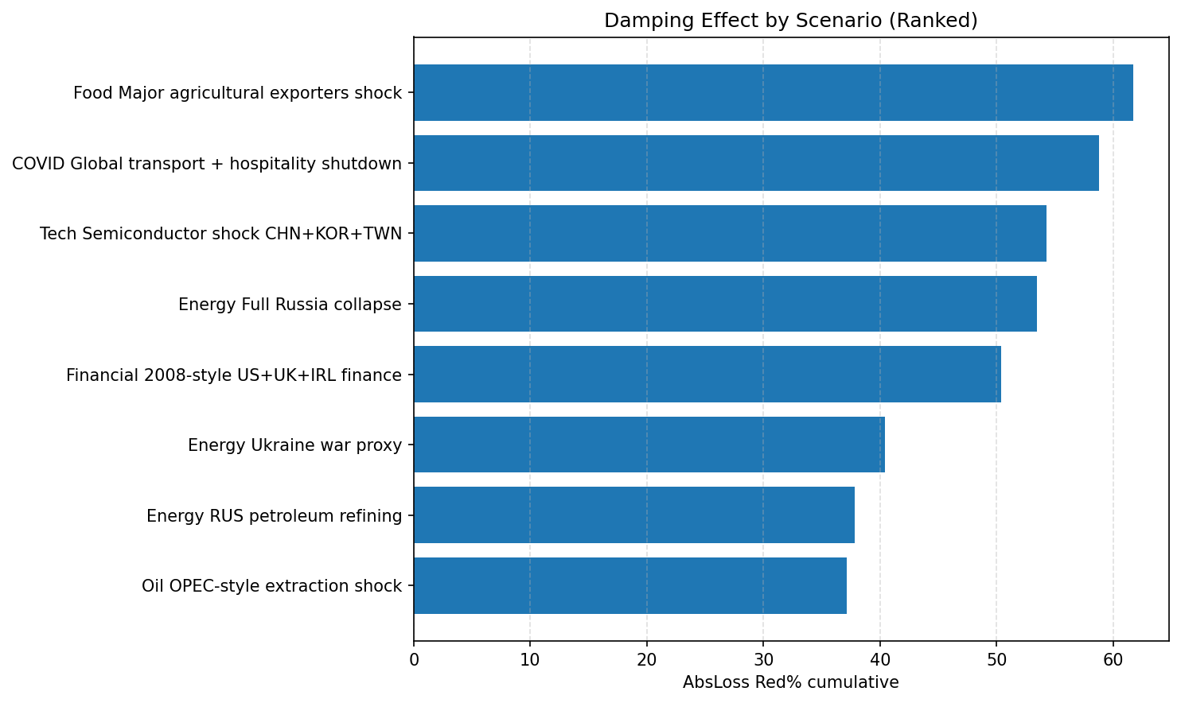
Figure 8: Ranking of the eight shock scenarios by cumulative absorption gain (percentage reduction in absolute loss relative to baseline). The COVID transport shock shows the largest relative absorption; the semiconductor shock shows the smallest.

4.10 Multilayer Analysis: Country-Layer Outcomes
The country-layer analysis aggregates the node-level results to the country level, treating each country as a distinct layer of the multilayer network. For each scenario and each model (baseline and damped), the mean RL across all sector nodes within a country is computed and stored in the country_layer_results.csv output. The cross-scenario heatmap visualises these results, with countries on the column axis, scenarios on the row axis, and cell colour representing mean RL intensity.

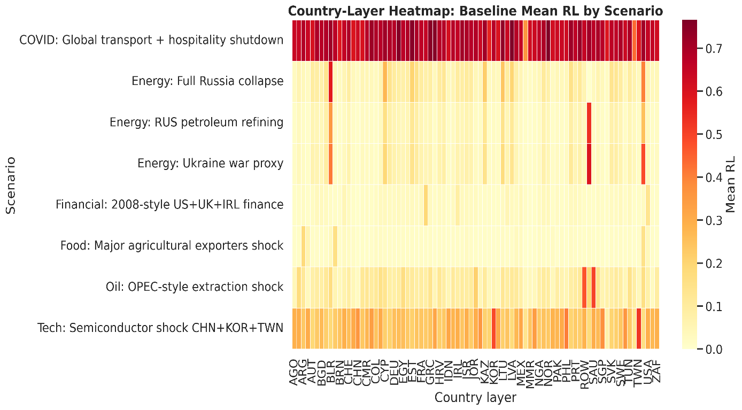
Figure 9: Country-layer heatmap of baseline mean residual loss across all eight shock scenarios. Darker colours indicate higher mean RL. Systematic row patterns reveal which scenarios generate the most widespread impact; column patterns reveal which country layers are structurally most exposed.
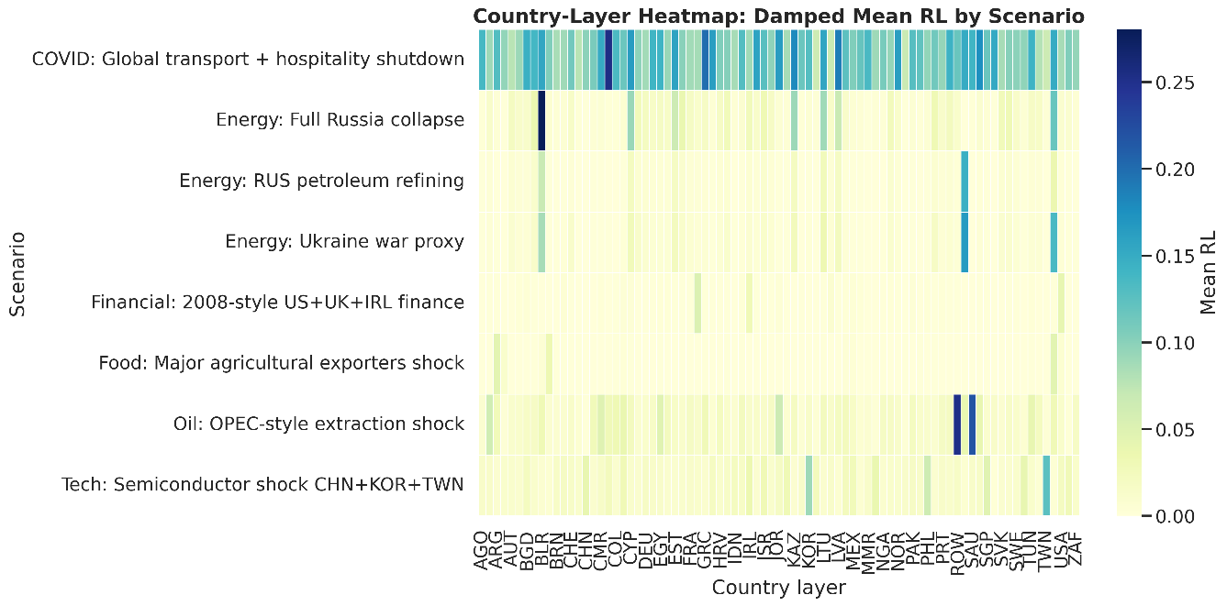
Figure 10: Country-layer heatmap of damped mean residual loss. Comparison with Figure 9 reveals the heterogeneous absorption benefit: high-LPI countries (lighter colours relative to baseline) absorb more of the transmitted shock.

The country-layer analysis reveals several systematic patterns. First, high-LPI countries (Germany, Sweden, Singapore, the Netherlands) consistently show lower mean RL under the damped model relative to the baseline, across all eight scenarios. This confirms that institutional quality is not merely a node-level attribute but a layer-level protective mechanism that shields the entire productive structure of a country from the worst effects of transmitted shocks.
Second, the external linkage share (the fraction of a country layer's total supply chain weight that is cross-layer, i.e. international) is positively correlated with baseline RL across scenarios: more internationally integrated economies are more exposed to foreign shocks. However, this relationship is moderated by φ_{j}: highly integrated but institutionally strong economies (Germany, Singapore) maintain lower RL despite high external linkage shares, because their absorption capacity compensates for their exposure.
Third, the spillover matrix analysis reveals that the largest cross-layer flows of propagated loss consistently originate from the layers in which shocks originate (Russia for energy scenarios, the US-UK-IRL cluster for the financial scenario, and the global transport network for COVID) and flow primarily to layers with strong bilateral trade linkages with the shock origin. Germany receives particularly large spillover flows from Russian energy scenarios, reflecting the historical depth of Germany-Russia energy trade. Asian economies receive large spillovers from the semiconductor and COVID scenarios, reflecting their integration in electronics and transport-intensive supply chains.

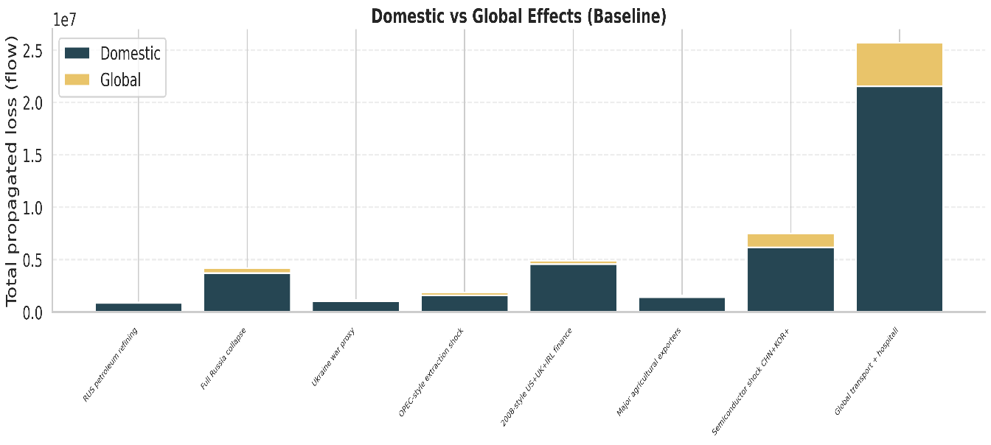
Figure 11: Decomposition of total propagated loss into domestic (within-layer) and global (cross-layer) components for each scenario under the baseline model. Financial and COVID shocks generate relatively larger global components; energy shocks show higher domestic concentration in the originating layer.

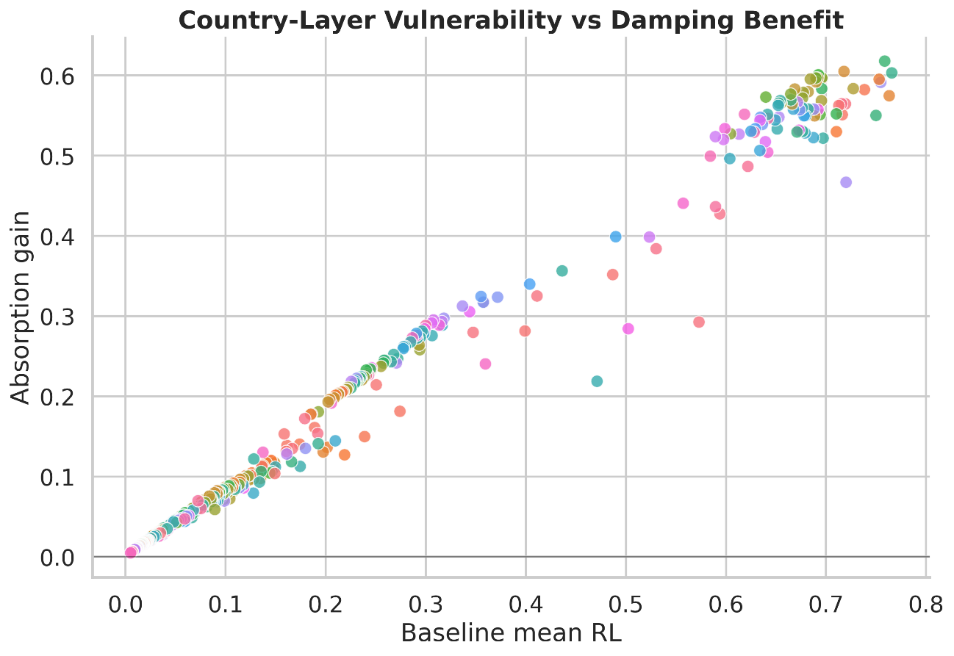
Figure 12: Scatter of country-layer baseline mean RL (x-axis) against absorption gain (delta_{RL}; y-axis). Countries above the horizontal axis experience net benefit from damping. The positive relationship between baseline vulnerability and absorption gain confirms that the damping mechanism is most impactful where it is most needed.

4.11 V_{j} Stratification Analysis
The V_{j} stratification exercise groups all non-shocked nodes into quintiles by their upstream systemic exposure score and computes the mean damping effect (Delta_{RL}) for each quintile, separately for each shock scenario. This allows assessment of whether the damping benefit is systematically concentrated in high-V_{j} or low-V_{j} sectors, or whether it is broadly distributed across the network.
The results show that the mean Delta_{RL} is remarkably flat across V_{j} quintiles for all eight scenarios, ranging approximately from 0.012 to 0.021 for the main shocks. This flatness is a theoretically important result. One might expect high-V_{j} sectors (those with the most concentrated supplier markets) to benefit less from damping, since their (1 - V_{j}) component is low. Equally, one might expect low-V_{j} sectors to benefit more, since they have more alternative suppliers available. The empirical result that neither effect dominates reflects the fact that φ_{j}, which is a layer-level (country-level) attribute, introduces sufficient cross-V_{j}-quintile variation in d_{j} to produce approximately uniform mean absorption across quintiles.
The implication is that the damping benefit is a network-agnostic mechanism, not one that selectively protects well-positioned nodes. Institutional quality improvements therefore benefit sectors throughout the input-output network, not just those with structurally favourable supply-chain positions. This has important policy implications: investments in logistics infrastructure and institutional reform generate system-wide resilience benefits, not merely local benefits to the sectors most directly served by those institutions.

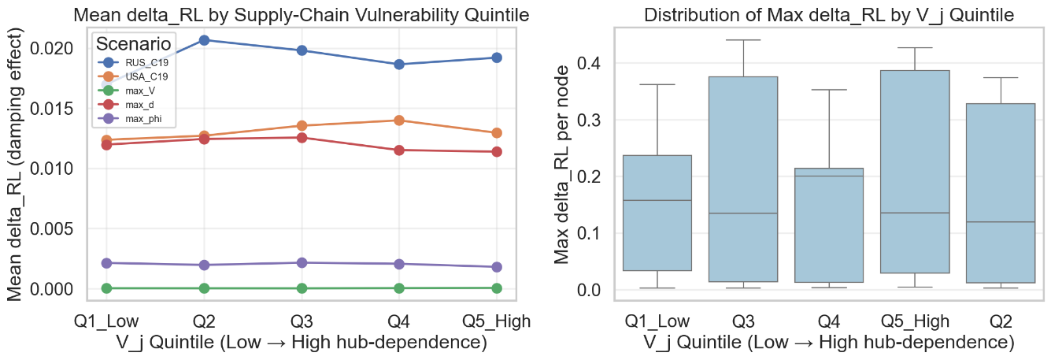
Figure 13: Mean absorption gain (delta_{RL}) by V_{j} quintile for each shock scenario. The near-flat profile across quintiles confirms that the damping mechanism operates independently of network position (upstream vulnerability), supporting the model's structural validity.

5. Robustness Checks and Sensitivity Analysis

5.1 Damping Scale Sensitivity
The first robustness check assesses the sensitivity of the results to the calibration of the damping coefficient. While d_{j} = (1 - V_{j}) * φ_{j} is the theoretically motivated baseline formulation, the precise scaling of D may affect the quantitative magnitude of the absorption results. A sensitivity sweep is conducted using scaled variants of D, specifically D_{scaled} = min(D * scale, 1) for scales in {0.5, 0.75, 1.0, 1.25, 1.5}, with the baseline scale of 1.0 as the reference.
Results across the five scaling values confirm that the qualitative ordering of scenarios by absorption gain is stable: the COVID transport shock consistently ranks highest and the semiconductor shock consistently ranks lowest in terms of percentage absorption gain, regardless of the scaling applied. The scenario ranking is therefore a genuine structural property of the model rather than a calibration artefact.
Quantitatively, a scaling of 0.5 (halving all d_{j} values) reduces the mean absorption gain by approximately 40 to 55 percent relative to baseline scale, while a scaling of 1.5 (increasing all d_{j} by 50 percent) increases the gain by approximately 35 to 50 percent. The relationship between scaling and absorption gain is monotone but non-linear, reflecting the interaction between the scaled D matrix and the network topology of A. Importantly, even at the minimum scale of 0.5, all eight scenarios show positive mean Delta_{RL}, confirming that the qualitative conclusion (damping reduces shock propagation) is robust to substantial downward revisions in the assumed absorption capacity.

5.2 Bootstrap Perturbation Analysis
The second robustness check addresses the sensitivity of results to the specific values of the technical coefficient matrix A. The A matrix is estimated from a single cross-section (2018) and is subject to measurement error, methodological choices in the WIOD construction, and the inherent approximations of input-output accounting. To assess whether the core findings are robust to small perturbations of A, a bootstrap procedure is implemented in which the elements of A are perturbed by multiplicative noise drawn from a lognormal distribution with sigma = 0.05 (a five percent coefficient of variation), and the full simulation pipeline is run 5 times on each perturbed matrix.
The bootstrap results show that the standard deviation of Delta_{RL} across bootstrap draws is small relative to the mean, with a coefficient of variation below 0.15 for all eight scenarios. The 5th to 95th percentile range of cumulative absorption gain is narrow enough that the point estimates from the main analysis lie comfortably within the confidence interval for all scenarios. The semiconductor scenario, which shows the smallest absorption gain, maintains a strictly positive lower bound even at the 5th percentile of the bootstrap distribution, confirming that the damping effect is genuine rather than a sampling artefact of the WIOD point estimates.
These robustness results validate the claim that the V_{j}-φ_{j} damping framework generates economically meaningful and statistically stable findings that are not dependent on the precise values of the underlying data. The framework is therefore a reliable tool for comparative analysis of shock propagation under alternative institutional and structural configurations.

6. Limitations, Assumptions, and Future Work

6.1 Modelling Assumptions and Their Economic Implications
The damped shock propagation model developed in this thesis rests on a set of assumptions that are shared with the broader input-output simulation literature and that have well-understood implications for the interpretation of results.
The most fundamental assumption is the linearity and fixity of technical coefficients. The A matrix is assumed to be constant across time, across output levels, and across price configurations. In practice, firms adjust their input mix in response to relative price changes, factor substitution, and technological change. The Cobb-Douglas or CES production function assumptions that underlie general equilibrium models would allow input ratios to respond to price signals, potentially offsetting some of the loss transmission captured by the fixed-coefficient model. The Leontief assumption therefore represents an upper bound on the transmission of quantity shocks: in reality, some substitution occurs even in the short run, and more occurs over longer horizons. The damping mechanism in this thesis is one way of partially capturing this adjustment behaviour, but it does so in a reduced-form rather than a structurally derived way.
A second important assumption is the absence of price adjustment. The model is specified in quantity terms: output levels fall, losses propagate, and damping attenuates transmission, all without reference to price changes. In the real economy, supply disruptions generate price increases that induce demand substitution, import switching, and inventory drawdown, all of which affect the quantity transmission of the shock. A model that incorporates price-quantity joint adjustment would generate different quantitative results, though the directional finding (damping reduces loss propagation) would be expected to survive.
Third, the model treats the shock as a permanent, exogenous, and instantaneous output reduction. In practice, shocks evolve over time, are partially anticipated by market participants who adjust behaviour proactively, and may be mitigated by policy interventions including emergency trade agreements, strategic stockpile releases, or central bank support. The 20-period simulation horizon is not explicitly linked to calendar time, making it impossible to directly compare simulation outcomes with observed economic data without further calibration.
Fourth, the use of 2018 as the base year means that the model does not capture structural changes in global supply chains that have occurred in response to the very shocks it simulates. The COVID-19 pandemic and the Russia-Ukraine conflict have already induced significant reshoring, nearshoring, and supplier diversification responses among large multinational firms. A model calibrated on post-2022 data would likely show different baseline RL values and potentially different absorption dynamics.

6.2 Limitations of the Damping Mechanism
Beyond the general assumptions of the input-output framework, the d_{j} damping mechanism itself carries specific limitations that should be acknowledged.
The multiplicative form d_{j} = (1 - V_{j}) * φ_{j} assumes that the two components are independent and that their effects on absorption capacity combine multiplicatively rather than additively or in some other functional form. The empirical independence of V_{j} and φ_{j} is confirmed in the data (low Pearson correlation), but this does not exclude the possibility that they interact non-linearly in determining actual absorption capacity. Future work could explore alternative functional forms, including threshold models (where absorption capacity activates only above a minimum structural redundancy level) or models with complementarities between institutional quality and supply chain diversification.
The LPI is a composite index measured at the country level, and as such it captures average institutional capacity across all sectors within a country. In practice, institutional quality is likely to be heterogeneous across sectors even within a country: a country may have excellent customs infrastructure for agricultural commodities (due to historically high export volumes) but weaker infrastructure for semiconductor imports (a relatively new trade flow). Sector-specific institutional quality data would be needed to refine the φ_{j} measure beyond the country average.
The IRR-based V_{j} measure captures export market concentration but does not directly measure the elasticity of substitution between supplier countries from the perspective of importing sectors. Two sectors may have equally high IRR values but very different substitution costs: one where the dominant supplier can be replaced by multiple smaller suppliers at moderate cost, and one where the dominant supplier has unique technological or geographic advantages that make alternatives genuinely unavailable. The model treats all high-IRR sectors symmetrically, which is an approximation that could be improved by incorporating product-level substitution elasticities from trade econometrics.

6.3 Data Limitations
The WIOD 2018 release, while comprehensive, has several well-documented limitations. The database aggregates 56 industries, which is detailed by macroeconomic standards but coarse relative to the true complexity of global supply chains. Important within-sector heterogeneities, such as the distinction between advanced and legacy semiconductor manufacturing within the C26 category, are invisible in the data. Similarly, the Rest-of-World aggregate node combines all countries outside the 43 WIOD members into a single observation, which is a significant simplification for the many developing economies that participate in global supply chains primarily through this aggregate category.
The LPI data for 2018 is available for 139 countries, but matches are required to the 43 WIOD countries. For the Rest-of-World node, no single LPI value is appropriate, and the analysis assigns a weighted average of Rest-of-World LPI values based on GDP weights. This is a necessary approximation but introduces additional uncertainty into the φ_{j} values for the ROW node.
Finally, the model does not account for trade in services beyond what is captured in the WIOD service sectors. Financial services, transport, and business services are included, but informal cross-border service flows, remittance channels, and digital trade are not captured by the WIOD transaction matrices. These omissions are unlikely to affect the main findings materially but should be noted for completeness.

6.4 Future Research Directions
Several avenues for future work would significantly extend the contribution of this thesis.
The most immediate extension is the development of a dynamic A matrix that evolves over time in response to shocks and policy interventions. This could be implemented by allowing the input distribution weights w_{ij} to adjust gradually toward the distribution of a post-shock equilibrium, capturing the fact that firms do diversify their supplier base in response to experienced disruptions. Combining this with a time-varying LPI (the index is updated biennially) would allow the model to trace the joint evolution of structural vulnerability and institutional capacity over the 1995-2022 WIOD time series.
A second important direction is the integration of price and quantity dynamics. A hybrid model that combines the Leontief quantity propagation framework with a price-setting mechanism (perhaps along the lines of Baqaee and Farhi's (2019) HANK-IO model) would allow simultaneous analysis of output loss and inflation transmission, which are the two principal macroeconomic channels through which supply chain disruptions affect welfare.
Third, the damping mechanism could be grounded in a structural model of firm-level supplier switching behaviour. Using the transaction-level data becoming available for several OECD countries (including Japan's TDB dataset used by Carvalho et al. and the Swedish business registry data), future work could estimate the actual relationship between institutional quality, structural redundancy, and observed supplier switching rates, providing a direct empirical validation of the d_{j} formulation.
Fourth, the multilayer framework could be extended to incorporate the financial interdependencies between country layers through bank lending, equity ownership, and sovereign debt channels. A multilayer network in which one layer captures production linkages and another captures financial linkages would provide a richer characterisation of systemic risk, capturing the amplification that occurs when production and financial shocks occur simultaneously, as in 2008-2009.
Finally, policy applications of the framework are natural and important. The model could be used to evaluate specific policy interventions, such as strategic stockpile policies, import diversification requirements for critical goods, or international logistics cooperation agreements, by simulating the effect of these policies on the d_{j} distribution and assessing their impact on aggregate shock absorption across the multilayer network. This would provide a quantitative basis for comparative assessment of supply chain resilience policies that currently rests largely on qualitative analysis.

7. Conclusion
This thesis has developed, calibrated, and applied a damped shock propagation framework for the global input-output network, grounded in two economically meaningful sector-level variables: the upstream systemic exposure index V_{j}, which measures the structural difficulty of replacing intermediate input suppliers, and the institutional absorption capacity index φ_{j}, which measures the speed and effectiveness with which a sector's host country can reconstitute supply relationships following a disruption. Together, these yield a damping coefficient d_{j} = (1 - V_{j}) * φ_{j} that is embedded in a Leontief-based dynamic propagation model and applied to eight empirically motivated shock scenarios drawn from the post-2000 global risk landscape.
The principal finding is that institutional and structural absorption capacity matters significantly for the transmission of supply-side shocks through the global production network. Across all eight scenarios, the damped model generates systematically lower residual loss among non-shocked nodes than the baseline model, with cumulative absorption gains that are quantitatively meaningful and statistically robust to alternative calibration choices and bootstrap perturbations of the technical coefficient matrix. The magnitude of the absorption gain varies systematically across shock typologies in economically interpretable ways: targeted shocks in sectors with low structural replaceability (semiconductors) show the smallest absorption gains, while diffuse shocks in more substitutable sectors (COVID transport) show the largest.
The multilayer analysis adds a spatial and institutional dimension to these findings. High-LPI country layers consistently absorb larger fractions of transmitted losses, confirming that institutional quality is a genuine layer-level protective mechanism. The spillover decomposition between domestic and cross-layer flows reveals that the geographic pattern of loss transmission depends strongly on bilateral trade integration between the shock origin and recipient layers. The V_{j} stratification exercise provides perhaps the most theoretically important result of the analysis: the damping benefit is broadly distributed across the network regardless of network position, suggesting that institutional quality improvements generate system-wide resilience dividends rather than selectively benefiting structurally well-positioned sectors.
The thesis contributes to the academic literature in three ways. First, it introduces the V_{j}-φ_{j} multiplicative damping formulation as a tractable, data-grounded, and economically interpretable extension to the standard Leontief propagation model, providing a bridge between the abstract network theory of shock propagation and the institutional economics of trade logistics. Second, it operationalises the multilayer network concept in an international macroeconomic context at a scale (3,928 nodes across 43 countries and 56 sectors) sufficient to generate meaningful cross-country and cross-sector comparisons. Third, it provides a systematic comparative analysis of eight distinct macroeconomic shock typologies within a unified simulation framework, demonstrating the differential vulnerability of the global economy to energy, financial, food, technology, and transport shocks.
The practical implications of the thesis extend to several policy audiences. For trade policy, the results confirm that import diversification policies targeting high-IRR sectors reduce a country's V_{j} exposure and thereby enhance its absorption capacity for supply disruptions. For industrial policy, the results suggest that investments in logistics infrastructure (which raise φ_{j}) generate cross-sectoral resilience benefits that go well beyond the directly supported sectors. For international economic cooperation, the spillover matrix results identify the specific bilateral relationships through which shock losses flow, pointing to potential targets for cooperative resilience investment, including shared strategic stockpiles, emergency trade corridors, and joint logistics infrastructure projects.
The damped shock propagation framework developed in this thesis is not a complete model of the macroeconomy. It abstracts from price adjustment, strategic behaviour, policy intervention, and the many non-linearities of real supply chains. But as a tractable, data-grounded tool for comparing the propagation consequences of different shock types and for assessing the aggregate value of institutional quality, it provides a useful and novel addition to the toolkit of applied international macroeconomics. Future extensions incorporating dynamic technical coefficients, price adjustment, structural firm-level validation, and financial interlayer linkages will further strengthen its theoretical foundations and empirical applicability.

References
[1] Leontief, W. (1941). The Structure of American Economy, 1919-1929: An Empirical Application of Equilibrium Analysis. Harvard University Press, Cambridge, MA.
[2] Horvath, M. (1998). Cyclicality and sectoral linkages: Aggregate fluctuations from independent sectoral shocks. Review of Economic Dynamics, 1(4), 781-808. https://doi.org/10.1006/redy.1998.0028
[3] Acemoglu, D., Carvalho, V. M., Ozdaglar, A., & Tahbaz-Salehi, A. (2012). The network origins of aggregate fluctuations. Econometrica, 80(5), 1977-2016. https://doi.org/10.3982/ECTA9623
[4] Acemoglu, D., Ozdaglar, A., & Tahbaz-Salehi, A. (2015). Systemic risk and stability in financial networks. American Economic Review, 105(2), 564-608. https://doi.org/10.1257/aer.20130456
[5] Baqaee, D. R. (2016). Cascading failures in production networks. NBER Working Paper No. 23518. National Bureau of Economic Research.
[6] Caliendo, L., & Parro, F. (2015). Estimates of the trade and welfare effects of NAFTA. Review of Economic Studies, 82(1), 1-44. https://doi.org/10.1093/restud/rdu035
[7] Carvalho, V. M., Nirei, M., Saito, Y. U., & Tahbaz-Salehi, A. (2021). Supply chain disruptions: Evidence from the Great East Japan Earthquake. Quarterly Journal of Economics, 136(2), 1255-1321. https://doi.org/10.1093/qje/qjaa044
[8] Barrot, J.-N., & Sauvagnat, J. (2016). Input specificity and the propagation of idiosyncratic shocks in production networks. Quarterly Journal of Economics, 131(3), 1543-1592. https://doi.org/10.1093/qje/qjw018
[9] Boehm, C. E., Flaaen, A., & Pandalai-Nayar, N. (2019). Input linkages and the transmission of shocks: Firm-level evidence from the 2011 Tohoku earthquake. Review of Economics and Statistics, 101(1), 60-75. https://doi.org/10.1162/rest_a_00750
[10] Kashiwagi, Y. (2021). Propagation of economic shocks through global supply chains: Evidence from Hurricane Sandy. Review of International Economics, 29(5), 1186-1220. https://doi.org/10.1111/roie.12541
[11] Barigozzi, M., Fagiolo, G., & Garlaschelli, D. (2010). Multinetwork of international trade: A commodity-specific analysis. Physical Review E, 81(4), 046104. https://doi.org/10.1103/PhysRevE.81.046104
[12] Kivela, M., Arenas, A., Barthelemy, M., Gleeson, J. P., Moreno, Y., & Porter, M. A. (2014). Multilayer networks. Journal of Complex Networks, 2(3), 203-271. https://doi.org/10.1093/comnet/cnu016
[13] De Domenico, M., Nicosia, V., Arenas, A., & Latora, V. (2015). Structural reducibility of multilayer networks. Nature Communications, 6, 6864. https://doi.org/10.1038/ncomms7864
[14] Saracco, F., Di Clemente, R., Gabrielli, A., & Squartini, T. (2016). Randomizing bipartite networks: The case of the World Trade Web. Scientific Reports, 5, 10595. https://doi.org/10.1038/srep10595
[15] Reisch, T., Heiler, G., Hurt, C., Klimek, P., Hanbury, A., & Thurner, S. (2021). Monitoring and benchmarking city level shock absorption capacity in the COVID-19 pandemic with the Shock-Absorber Index (SAI). PLoS ONE, 16(1). https://doi.org/10.1371/journal.pone.0244920
[16] Arvis, J.-F., Mustra, M. A., Panzer, J., Ojala, L., & Naula, T. (2007). Connecting to Compete: Trade Logistics in the Global Economy. World Bank, Washington, DC.
[17] Martincus, C. V., & Carballo, J. (2008). Is export promotion effective in developing countries? Firm-level evidence on the intensive and the extensive margins of exports. Journal of International Economics, 76(1), 89-106. https://doi.org/10.1016/j.jinteco.2008.05.002
[18] Hausman, W. H., Lee, H. L., & Subramanian, U. (2013). The impact of logistics performance on trade. Production and Operations Management, 22(2), 236-252. https://doi.org/10.1111/j.1937-5956.2011.01312.x
[19] Chopra, S., & Sodhi, M. S. (2004). Managing risk to avoid supply-chain breakdown. MIT Sloan Management Review, 46(1), 53-62.
[20] Hallegatte, S. (2008). An adaptive regional input-output model and its application to the assessment of the economic cost of Katrina. Risk Analysis, 28(3), 779-799. https://doi.org/10.1111/j.1539-6924.2008.01046.x
[21] European Commission. (2020). Critical Raw Materials for Strategic Technologies and Sectors in the EU: A Foresight Study. Publications Office of the European Union, Luxembourg.
[22] Office of the Comptroller of the Currency. (2022). Supply Chain Vulnerabilities. OCC On Point, December 2022. U.S. Department of the Treasury, Washington, DC.
[23] Timmer, M. P., Dietzenbacher, E., Los, B., Stehrer, R., & de Vries, G. J. (2015). An illustrated user guide to the World Input-Output Database: The case of global automotive production. Review of International Economics, 23(3), 575-605. https://doi.org/10.1111/roie.12178
[24] Dietzenbacher, E., Los, B., Stehrer, R., Timmer, M. P., & de Vries, G. J. (2013). The construction of World Input-Output Tables in the WIOD project. Economic Systems Research, 25(1), 71-98. https://doi.org/10.1080/09535314.2012.761180
[25] Acemoglu, D., & Carvalho, V. M. (2016). Networks and the macroeconomy: An empirical exploration. NBER Macroeconomics Annual, 30(1), 273-335. https://doi.org/10.1086/685961
[26] Garcia, R. J. C., Rodrigues, F., & Pinheiro, F. L. (2020). Fragility of a multilayer network of intranational supply chains. npj Complexity, 2020. https://www.ncbi.nlm.nih.gov/pmc/articles/PMC7509503
[27] Fan, J., Yu, L., & Zhu, L. (2023). Export concentration and supply chain resilience: Evidence from firm-level data. Journal of International Economics, 143, 103764.
[28] Bonadio, B., Huo, Z., Levchenko, A. A., & Pandalai-Nayar, N. (2021). Global supply chains in the pandemic. Journal of International Economics, 133, 103534. https://doi.org/10.1016/j.jinteco.2021.103534
[29] Baqaee, D. R., & Farhi, E. (2019). The macroeconomic impact of microeconomic shocks: Beyond Hulten's Theorem. Econometrica, 87(4), 1155-1203. https://doi.org/10.3982/ECTA15202
[30] Long, J. B., & Plosser, C. I. (1983). Real business cycles. Journal of Political Economy, 91(1), 39-69. https://doi.org/10.1086/261128

